Project Design Phase-II Technology Stack (Architecture & Stack)

Date | 17 February 2026
Team ID | LTVIP2026TMIDS66150
Project Name | Prosperity Prognosticator: Machine Learning for Startup Success Prediction
Maximum Marks | 4 Marks

Technical Architecture:
The system architecture for the Prosperity Prognosticator project integrates startup data preprocessing, machine learning model training and evaluation, and a Flask-based web application for real-time startup success prediction. The system allows users to input startup characteristics and receive success predictions generated by trained machine learning models.
Reference: Self-defined system design and implementation based on project requirements and team discussion
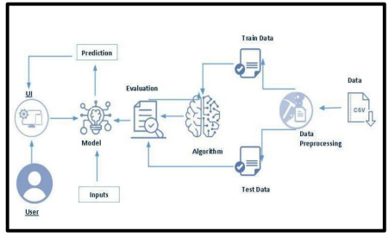

Table-1: Components & Technologies

S.No | Component | Description
1 | User | Entrepreneur or investor who provides startup details and views prediction results
2 | User Interface (UI) | Web interface that allows users to input startup features and view predictions
3 | Input Module | Accepts startup-related parameters such as funding, market type, and business attributes
4 | Dataset (CSV) | Historical startup dataset used for training and testing the ML model
5 | Data Preprocessing | Performs data cleaning, feature encoding, normalization, and preparation
6 | Training Data | Portion of dataset used to train the machine learning algorithm
7 | Testing Data | Portion of dataset used to evaluate model performance
8 | Machine Learning Algorithm | Algorithm used to learn patterns from startup data (e.g., Random Forest, Logistic Regression)
9 | Model | Trained machine learning model generated from the algorithm
10 | Evaluation Module | Evaluates model performance using metrics such as accuracy and precision
11 | Prediction Module | Generates startup success prediction based on user inputs

Table-2: Application Characteristics

Step No | Source | Process | Destination
1 | User | Startup details entered | User Interface
2 | User Interface | Sends inputs | Prediction Model
3 | Dataset (CSV) | Raw data processing | Data Preprocessing
4 | Data Preprocessing | Split dataset | Training & Testing Data
5 | Training Data | Train algorithm | Machine Learning Model
6 | Testing Data | Test model | Evaluation Module
7 | Evaluation Module | Validate performance | Approved Model
8 | Model | Generate prediction | Prediction Module
9 | Prediction Module | Display results | User Interface

Table-3: Technology Mapping
Component | Technology Used
User Interface | HTML, CSS, JavaScript, Flask
Data Storage | CSV files
Data Preprocessing | Python, Pandas, NumPy
Machine Learning Algorithm | Scikit-learn
Model Evaluation | Accuracy, Precision, Recall
Model Storage | Joblib / Pickle
Deployment | Flask (Local / Cloud-ready)

